**Cultural Heritage Promotion and Preservation**

* Importance of cultural preservation
* Why this traditional/cultural still need to be perform to date.
* What are the benefits of cultural heritage promotion and preservation.

**CONTENT**

\***Menu**: Home | Events | Gallery | Contact | About Us*



**Home Page:**

1. Some info why this website made.
2. What is the website main advocacy.
3. Brief explanation why cultural heritage promotion and preservation is important.

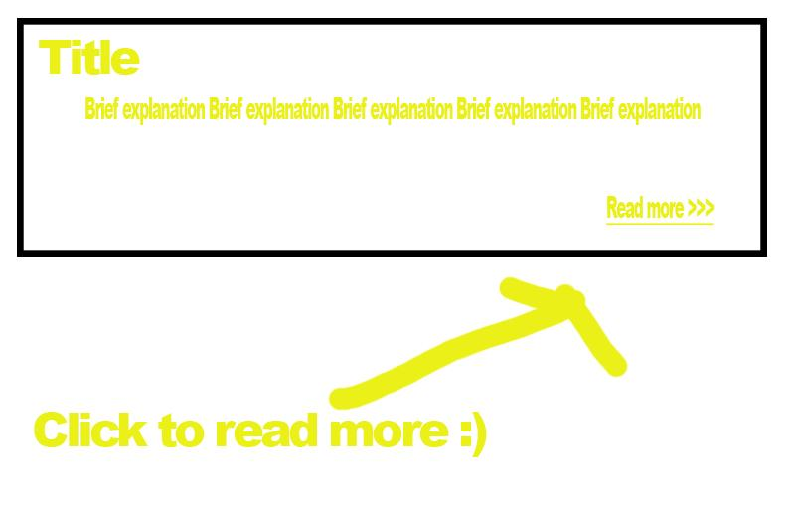

1. Some pictures/videos of cultural/traditional events performed. Explain why this events is important.



**Events Page:**

1. List of events
2. Events pictures,videos and info (date,description,importance of the event).

**Gallery Page:**

Mga pictures lang hehehe.